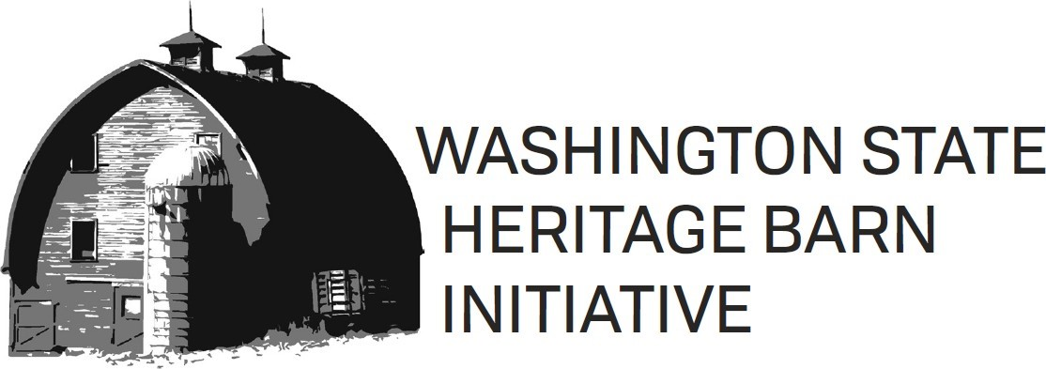

**Application Template**

2025-2027 BIENNIUM

Grant applications are due **Sunday, October 19, 2025 at 11:59pm**

Contact Information:

[grants@preservewa.org](mailto:grants@preservewa.org)

(206) 624-9449

 

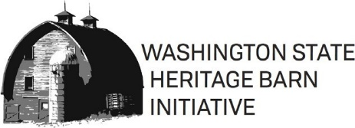 **APPLICATION TEMPLATE**

2025 – 2027 BIENNIUM

2025 HERITAGE BARN GRANT APPLICATION

Please use this Application Template to complete your responses to all questions on the application form. Once you have typed out your responses in this template, you can simply copy and paste your narrative responses into the online application form.

Please use the [Grant Program Guidelines and Procedures](https://preservewa.org/wp-content/uploads/2023/08/Barns-Guidelines-and-Procedures-2023_2025.pdf) document as a reference when completing this template. The Guidelines and Procedures document provides more detailed instructions/explanations on each question.

Remember, once you begin completing the application online, you cannot ‘Save’ your work and come back to it later: the full online application form must be completed and submitted in one sitting.

SECTION 1- Property Information

**Current Barn/Farm Name**:

**Historic Barn/Farm Name(s)** (*if known*):

**Barn Physical Street Address**:

**City**:

**ZIP**:

**County**:

**Geographic Coordinates** (*Approximate coordinates of where the barn is located*):

**Parcel Number:**

**Legal Description:**

Please indicate the **Washington State Legislative District** in which your barn is located:

*To find your legislative district by address,* [*click here*](https://app.leg.wa.gov/districtfinder)*.*

SECTION 2 - OWNER INFORMATION

**Owner Name**:

*If owned by an organization, please also include a point of contact person here.*

**Owner Mailing Address**:

**Owner Phone Number**:

**Owner Email**:

Please indicate the **Washington State Legislative District** in which you live: [*Complete this field even if you live in the same district in which your barn is located.]*

*To find your legislative district by address,* [*click here*](https://app.leg.wa.gov/districtfinder)*.*

## SECTION 3 - APPLICANT INFORMATION

**Owner Authorization**

[*the online form will ask you to check one of the options*]

* I am the owner of the barn.
* I am not the owner of the barn, but have been authorized.

**Preferred Contact**

[*the online form will ask you to check all contact methods you are comfortable with*]

* Email
* Text Message
* Phone Call
* Video Call (Zoom)

## SECTION 4 - BUILDING DESCRIPTION

**Date(s) of Barn/Farm Construction** (if known):

**Barn Width** (in feet):

**Barn Length** (in feet):

**Barn Height** (in feet):

**Original/Historic Use of Barn**:

**Current Use of Barn**:

**Historical and Cultural Significance**:

**Designation Status of the Property**

[*the online form will ask you to check all that apply*]

* National Register of Historic Places
* WA Heritage Register
* WA Heritage Barn Register
* Local Historic Designation
* None
* Unknown

**Other Restrictions**:

SECTION 5 – BUILDING CONDITION ASSESSMENT

The online form will ask you to **select Good, Fair, Poor, Failing** (needs replacement), or n/a for each of the following barn elements:

* Foundation
* Foundation Sill Plates
* Roof Sheathing/Cladding
* Roof Structure/Rafters
* Structural Posts
* Structural Beams
* Exterior Wall Framing
* Exterior Siding
* Windows and/or Doors
* Outbuildings, Systems, and/or Built-in Equipment

**Barn Condition Description**:

**Barn Maintenance and Repair History**:

## SECTION 6 - PROJECT PROPOSAL & BUDGET

The online form will list the four (4) work types that all barn rehabilitation work falls under: Roof Replacement, Structural Stabilization, Exterior Rehabilitation, and Interior Rehabilitation. On the application form, you will check each of the Work Types relevant to your application. For each Work Type selected, you will need to answer the following:

**Describe in detail the steps of this phase of the project including treatments, techniques, and materials used**:

**Indicate the timeline in which this work phase will be completed**:

**Indicate the cost of this work phase**:

For example, if you select Roof Replacement and Structural Stabilization as the two Work Types involved in your project, you will have to answer the above three (3) questions for both Work Types.

**Project Total Cost**:

**Grant Request**:

You can request up to 50% of your PROJECT TOTAL COST but not more than $75,000.

**Understanding of Project Total**

[*This is a ‘check-box’ field on the online application form - this box must be checked on the form in order for the application to be complete*]

SECTION 7 - CASH MATCH AND IN-KIND MATCH WORKSHEET

All applicants must download and complete the following [Cash & In-Kind Match Worksheet](https://preservewa.org/wp-content/uploads/2025/08/Cash-In-Kind-Match-Workseet.pdf) in order to provide a visual representation of your overall project cost and sources of income. You can download the document at the following link: Cash & In-Kind Match Worksheet. Applicants will be required to upload the completed worksheet to the online application form.

**Experience & Qualifications**:

**Financial Need**:

## SECTION 8 - PUBLIC BENEFIT

**Visibility from the Public Right-of-Way**:

**Alternative Public Access**:

**Preservation Easement**:

* Yes
* No

[*This is a yes-or-no check box field on the online application form. Easements are required for all grant awards – checking ‘no’ will result in an ineligible application.*]

**Long Term Maintenance**:

**Additional Information**:

SECTION 9 – ATTACHMENTS

**The following documents/files should be on hand, ready to upload when you begin completing the online application form**:

* Contractor bids, estimates, condition assessments, etc.
* Images of or product pages for proposed materials for the project work
* Building images: four to twelve images showing all four sides of the barn
* Detail images: up to fifteen images showing the condition of the area(s) of the proposed work and the need for/urgency of repair
* Context image: image showing the view of the barn from the public right of way
* For applicants who are not the owner of the barn: correspondence/communication from the owner providing authorization to apply for a barn grant
* Optional (for Local Government applicants): a brief profile of department mission, lead staff, and annual budget
* Optional (for Non-Profit Organization applicants): a list of board members and their affiliations and an annual operating budget for most recently completed fiscal year

SECTION 10 – CERTIFICATION

The online application form will ask for your name to be entered as a digital signature on the application.